August 26, 2021

SEPTEMBER MONTHLY MEETING NOTICE

TO ALL MEMBERS OF TEAMSTERS LOCAL 205

The Regular Monthly Meeting for September will be held on Tuesday, September 14, 2021 at 7:00 p.m. at the

WHITE OAK AMERICAN LEGION
(DOWNSTAIRS)
2813 CAPITOL STREET
WHITE OAK, PA 15131

You must show your Union identification card to be admitted to this meeting!

Fraternally yours,
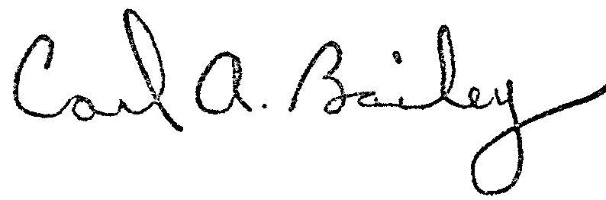
Carl A Bailey
Secretary- Treasurer
CAB/lmm

Steward: Please post meeting notice!

